Abstract
A new dynamic crop growth model based on empirical derived allometric partitioning rules was developed for winter oilseed rape. The model simulates dry matter production, nitrogen uptake and distribution, leaf, stem and pod area expansion and yield formation under optimal and water- and nitrogen-limited conditions.
The model includes specific aspects as hibernation, senescence due to self-shading, freezing and aging, translocation of assimilates and nitrogen, light absorption and reflection by flower layer and oil synthesis. It was parameterized with two data sets from Hohenschulen, northern Germany, and validated with datasets from Germany France, Great Britain and the Czech Republic.
Model performance in terms of prediction of total aboveground dry matter production and allocation of dry matter between vegetative and generative plant parts was good. In addition, nitrogen uptake and distribution are well represented. In contrast, year-to-year variability of final seed yield was not well estimated due to variation in the harvest index, which was not well predicted. Relative differences in seed yield due to sowing date and nitrogen application were well reproduced in most cases.

Introduction
Winter oilseed rape (WOSR, Brassica napus L.) has become an important crop for food and biodiesel production, especially in Germany, France and UK (FAOstat). It is therefore of high importance that the crop growth is well understood. Crop growth and yield are influenced by the complex interaction of management (e.g. sowing date, fertilization strategy) with environmental factors, including weather, soil texture, water and nutrient availability (e.g. Mendham et al. 1981, Asare and Scarisbrick 1995). During recent decades the average yield was increased due to breeding progress and management optimization, but this has not improved yield stability (Rondanini et al. 2012) and yield variability of WOSR is still high (Berry and Spink, 2006).
Simulation models can be an effective tool to analyze and optimize the development and yield formation of WOSR under different environmental conditions. Most plant growth models available for WOSR were developed and published during the 1990s. During recent years, new effort has been given to developing and adapting rapeseed models (Deligios et al. 2013; Jing et al. 2016; Hoffman et al. 2015, Robertson & Lilley 2016, He et al. 2017), because of the increased importance of the crop for food production and biodiesel. However, none of the published simulation models for WOSR is able to sufficiently simulate crop growth and yield in different environments under nitrogen (N) and water limitation (Yin et al., 2017). In addition, the available models often do not consider all rapeseed-specific yield limiting processes and the data base for parameterization has often been scarce.
The LINTUL-BRASNAP model, published by Habekotté (1997) is only parameterized for optimum growth conditions and does not simulate autumn and winter growth. The CERES-RAPE model from Gabrielle et al. (1998) is parameterized for fully irrigated crops. Petersen et al. (1995) adapted the DAISY model to WOSR data, but important processes as leaf loss due to senescence and partitioning of dry matter between pods and vegetative parts after flowering are not included. The newly adapted model CSM-CROPGROW, which is based on the DSSAT model, was used for data from Mediterranean environments (Deligios et al. 2013) and Canada (Jing et al. 2016). The APSIM model family was recently enriched with a rapeseed model (Hoffman et al. 2015, Robertson & Lilley 2016, He et al. 2017). All models share the approach that potential growth is estimated from the product of absorbed photosynthetic active radiation (PAR) and light use efficiency (LUE), which is either constant or changes with development stage. One of the most important development stages for yield formation is pod growth and ripening (Weymann et al. 2015, Lilley et al. 2018). Within this phase, seed filling takes place (Diepenbrock 2000). In LINTUL-BRASNAP, it is estimated from the accumulation and redistribution of carbohydrates, maximal growth rate per individual seed and seed density (Habekotté 1997). In contrast, CERES-RAPE simulates the partitioning of assimilates among pod walls and seeds by an allometric approach (Gabrielle et al. 1998) but for other DM fractions a phenological driven approach is used.
Recently, Weymann et al. (2017) published a study analyzing DM and N partitioning as well as variation of specific leaf area of winter oilseed rape under varying N supply and sowing dates. The comparable detailed data set and the allometric relationships established enable a direct, regression based parameterization of partitioning algorithms from experimental results. A recent comparison of partitioning algorithms for winter wheat (Ratjen et al. 2018) supports the view that allometric approaches may be superior to phenological driven partitioning algorithms. Aim of the current study was to develop and evaluate a plant growth model for WOSR, based on these allometric partitioning algorithms and capable of estimating crop growth of WOSR under different environmental conditions and N treatments. The model has to be completed with, senescence processes and translocation of assimilates and N..

Material and methods

Data sets
The model was parameterized and validated with six independent data sets (Table 1). In Table 2, the measured physiological plant parameters and the frequency of measurements are shown.

Calibration data set
Model parameters were calibrated with data from Hohenschulen (Table 1, data sets 1 and 2). One field trial was performed during the vegetation periods 2004/05 and 2005/06 (data set 1). The second field trial was performed in 2009/10, 2010/11 and 2012/13 (data set 2). Hohenschulen is located in northwestern Germany (54.3°N, 10.0°E, 30 masl) with humid climate, influenced by the Baltic Sea. The average annual rainfall is 757 mm and mean temperature is 8.7°C (1981 - 2010). Weather conditions during the experimental periods are shown in Table 3. The main soil type at Hohenschulen is sandy loam with a pH value of 6.4 and a plant available water holding capacity to the maximum rooting depth of about 184 mm.
Table 1: Data sets for calibration and validation
Data set 1 | Site(s): Hohenschulen (Germany)  Years: 2004/05 - 2006/07  Treatments: N fertilization in spring (0, 80, 200, 240 kg ha⁻¹)
Data set 2 | Sites(s): Hohenschulen (Germany)  Years: 2009/10 - 2010/11, 2012/13  4 sowing dates  Treatments: N fertilization in autumn (0, 30, 60, 90 kg ha⁻¹), N fertilization in spring (0, 80, 160, 240, 280 kg ha⁻¹)
Data set 3 | Site(s): Hohenschulen (Germany)  Years: 2003/04 - 2005/06  - sowing dates  Treatments: N fertilization in spring (0, 80, 120, 160, 200, 240 kg ha⁻¹)
Data set 4 | Site(s): Hohenschulen (Germany)  Years: 1990/91 - 1998/99  Treatments: N fertilization in spring (0 - 240 kg ha⁻¹)
Data set 5 | Site(s): Châlons (France)  Years: 1994/95  Treatments: N fertilization (0, 135, 270 kg ha⁻¹)
Data set 6 | 14 Sites in Germany (Berge, Borwede, Christgrün, Dornburg, Futterkamp, Groß-Gerau, Gülzow, Hohenschulen, Kümbdchen, Moosburg, Nomborn, Ohrensen, Roda, Thyrow)  Years: 2005/06 - 2008/09  - sowing dates  N-unlimited
Data set 7 | 2 sites in Czech republic (Domaninek and Lednice)  Years: 1998-2002, 2003-2007 and 2011-2014  2 sowing dates  Nitrogen fertilization (90 – 225 kg ha⁻¹)
Data set 8 | 3 Sites in Germany (Biestow, Christgrün, Forchheim)  Years: 1992-2012  Treatments: N-unlimited  Variety trials
Data set 9 | 4 sites in the United Kingdom (High Mowthorpe, Rosemaund, Terrington, Thornholme)  Years: 2009 and 2010  Treatments: N fertilization (0, 60, 120, 180, 240, 300, 360 kg N ha⁻¹)

Table 2: Measured physiological plant parameters and frequency of measurements in each data set (VE: end of growing period in winter, VA: start of regrowth in spring, OF: onset of flowering, EF: end of flowering, DM: dry matter, Nc: Nitrogen concentration, SLA: specific leaf area)
Data set | 1 | 2 | 3 | 4 | 5 | 6 | 7 | 8 | 9
Frequency of measurements | about every 2nd week from VA until maturity | 2-4 times from emergence until VA | VE,VA and OF, EF | 3-11 times from emergence until maturity | every 2nd week | VE, VA |  |  | VA, OF, maturity
DM_{Shoot} | x | x | x | x | X | x |  |  | x
DM_{Leaf} | x | x |  |  | X |  |  |  | x
DM_{Stem} | x | x |  |  | X |  |  |  | x
DM_{Gen} | x |  |  |  | X |  |  |  | x
DM_{Seed} |  |  |  |  | X |  |  |  | x
DM_{Hull} |  |  |  |  | X
DM_{Root} |  | x |  |  | X
Nc_{Shoot} | x | x | x | x | X | x |  |  | x
Nc_{Leaf} | x | x |  |  |  |  |  |  | x
Nc_{Stem} | x | x |  |  |  |  |  |  | x
Nc_{Gen} | x |  |  |  | X |  |  |  | x
Nc_{Root} |  | x |  |  | X
Green-Area-Index | x | x |  |  | X | (x) |  |  | x
Leaf-Area-Index | x | x |  |  | X
Stem-Area-Index | x | x
Pod-Area-Index | x
SLA | x | x |  |  | X
Seeds/m² | x | x
1000-seed weight | x | x | x
Protein content |  | x
Oil concentration |  | x |  |  |  | x |  |  | x
Yield | x | x | x | x | X | x | x | x | x
Phenology |  |  |  |  |  |  | x | x
SWC (daily) |  |  |  |  |  |  | x
Table 3: Precipitation and temperature at the experimental station Hohenschulen
 | 2004 | 2005 | 2006 | 2009 | 2010 | 2011 | 2012 | 2013
Annual rainfall [mm] | 705 | 617 | 636 | 669 | 684 | 951 | 787 | 654
Annual mean temperature [°C] | 9.0 | 9.4 | 9.7 | 8.7 | 7.1 | 8.8 | 8.1 | 8.1

Data set 1 contained four N treatments (0 kg N ha⁻¹, 80 kg N ha⁻¹, 160 kg N ha⁻¹, 240 kg N ha⁻¹), which were supplied as ammonium nitrate/urea solution in two applications at the beginning of regrowth in spring and the beginning of stem elongation. Sowing dates and seeding density were chosen according to recommended management practice. Dry matter and N content of vegetative and generative plant parts were repeatedly measured from sowing until harvest, primarily during spring growth. At harvest, yield components (seed yield, 1000-seed weight, number of seeds per m²) were recorded. Furthermore, soil water content and soil mineral N content up to 90 cm depth were determined several times during the whole vegetation period.
Data set 2 contained 4 sowing dates, 4 autumn N application levels (0 kg N ha⁻¹, 30 kg N ha⁻¹, 60 kg N ha⁻¹, 90 kg N ha⁻¹) and 5 N application levels in spring (0 kg N ha⁻¹, 80 kg N ha⁻¹, 160 kg N ha⁻¹, 240 kg N ha⁻¹, 280 kg N ha⁻¹), in total 80 management combinations. Shoot and root dry matter and N content, green area index, soil water content and soil mineral N were measured from sowing until start of regrowth in spring. In addition, seed yield, 1000-seed weight and number of seeds per m² were recorded at harvest.
Crop management in these experiments, apart from N fertilization, followed recommended conventional practices to allow for optimal yield formation.

Validation data set
The model was validated with data from four independent series of field experiments (Table 1, data sets 3 – 13). These data were collected from different experiments and locations across Northern Europe (Table 1)
Data set 3 consisted of measurements in a field experiment at Hohenschulen in Germany, performed between 2004 and 2006 with two sowing dates and different spring N fertilization levels (0, 80, 120, 160, 200 and 240 kg N ha⁻¹).
Data set 4 contained measurements from a long-term field trial at Hohenschulen between 1991 and 1999 (Sieling et al., 2000). Within this experiment, effects of management practices as tillage, fungicides and fertilization were investigated in a winter oilseed rape - winter wheat - winter barley rotation. In our study, we only used data for the different mineral N fertilization rates in winter oilseed rape. Therefore, we only used data from plots that were tilled and treated with fungicides according to common practice and did not use livestock manure. The mineral N application in spring varied between 0 kg N ha⁻¹ and 240 kg N ha⁻¹.
Data set 5 was collected at Châlons (France, 48.5°N, 2.15°E, 83 masl) during the season 1994/95. The experiment contained three fertilizer N rates (0, 135 and 270 kg N ha⁻¹), arranged in a split-plot design with three replicates (Gosse et al., 1999).
Data set 6 was performed between the seasons 2005/06 and 2008/09 at 14 experimental sites, distributed over Germany. Location, soil characteristics and experimental periods of each site are given in Table 4.
Data set 7 was collected at two sites in Czech Republic (Domaninek and Lednice) during the periods 1998-2002, 2003-2007 and 2011-2014. The data consists of experiments with a normal amount of fertilizer added, with two different fertilization rates and two different sowing dates. Location, soil characteristics and experimental periods of each site are given in Table 4.
Data set 8 was collected at three sites in Germany (Biestow, Christgrün and Forchheim) over the period 1992-2012. At all three sites the latest years variety trials with 22 varieties was conducted. Location, soil characteristics and experimental periods of each site are given in Table 4.
Data set contains measurements from 4 sites in the United Kingdom (High Mowthorpe, Rosemaund, Terrington, Thornholme) where different amounts of nitrogen fertilization were tested (0, 60, 120, 180, 240, 300, 360 kg N ha⁻¹). These experiments were conducted in 2009 and 2010.
Table 4: Geographical position and main characteristics of each site of the data set 6 with experimental data from sites in Germany.
Dataset | Site | Geographical position | Height [m] | Main soil type | Experimental period(s)
1 | Hohenschulen | 54.3°N, 10.0°E | 30 | sandy loam | 2004/05 - 2006/07
2 | Hohenschulen | 54.3°N, 10.0°E | 30 | sandy loam | 2009/10 - 2010/11, 2012/13
3 | Hohenschulen | 54.3°N, 10.0°E | 30 | sandy loam | 2003/04 - 2005/06
4 | Hohenschulen | 54.3°N, 10.0°E | 30 | sandy loam | 1990/91 - 1998/99
5 | Châlons | 48.5°N, 2.15°E | 83 |  | 1994/95
6 | Berge | 52.4°N, 12.5°E | 35 | loamy sand | 2009
 | Dornburg | 51.0°N, 11.4°E | 235 | clayey silt | 2006-2009
 | Futterkamp | 54.2°N, 10.4°E | 56 | sandy loam | 2006-2009
 | Groß-Gerau | 49.6°N, 8.3°E | 88 | sandy loam | 2009
 | Gülzow | 53.5°N, 12.3°E | 26 | loamy sand | 2006-2009
 | Hohenschulen | 54.3°N, 9.6°E | 25 | sandy loam | 2006-2009
 | Moosburg | 48.3°N, 11.6°E | 421 | sandy loam | 2006-2009
 | Ohrensen | 53.3°N, 9.3°E | 19 | loamy sand | 2009
 | Roda | 51.3°N, 12.3°E | 224 | clayey silt | 2006-2009
 | Thyrow | 52.1°N, 13.1°E | 40 | silty sand | 2009
 | Nomborn | 50.3°N, 7.6°E | 290 | sandy loam | 2009
 | Christgrün | 50.3°N, 12.1°E | 370 | sandy loam | 2006
 | Kümbdchen | 49.6°N, 7.3°E | 345 | loamy sand | 2009
 | Borwede | 52.5°N, 8.4°E | 49 | sandy silt | 2006-2009
7 | Domaninek | 49.5°N, 16.2°E | 49 | loam | 1998-2002, 2003-2005, 2006-2007 and 2011-2014
 | Lednice | 48.8°N, 16.8°E | 54 | silty loam | 1999-2002 and 2005-2006
8 | Biestow | 54°N, 12°E | 45 | sandy loam/loamy sand | 1992-2002, 2005-2010 and 2011-2012
 | Christgrün | 51°N, 12°E | 430 | sandy loam | 1995-2002, 2003-2007, 2008-2010 and 2011-2012
 | Forchheim | 50°N, 11°E | 269 | sandy loam | 1997-2008 and 2009-2012
9 | High Mowthorpe | 54.1°N, 0.6°W | 175 | silty clay loam | 2009
 | Rosemaund | 52.1°N, 2.6°W | 59 | sandy clay loam | 2009-2010
 | Terrington | 52.7°N, 0.3°E | 2 | silty clay loam | 2009-2010
 | Thornholme | 54.1°N, 0.3°W | 15 | silty clay loam | 2010

Model
The model is based on previous work from Müller (2009), who developed a plant growth model for WOSR during vegetative growth. Here the model is extended for the entire growing season.

Phenological model
The phenological model is already described in Boettcher et al. (2016). Emergence depends on temperature sum and occurs at about 164 growing degree days with a base temperature of 3°C after sowing. Crop development after emergence is simulated to be determined by temperature (including vernalization) and photoperiod. Leaf development and shoot extension are calculated by considering phyllochron and internode extension. Growth stages were recorded according to the BBCH scale (Lancashire et al. 1991): emergence (00-09), leaf development (10-19), stem elongation (30-39), inflorescence emergence (50-59), flowering (60-69), and the pod development-maturation period (70-89). The growth stages on the BBCH scale were transformed into growth stages based on the EC scale (Schuette et al. 1982). This scale, which is a pre-stage of the BBCH scale, was chosen, because it is better adapted to the growth of dicot plants.

Plant growth model

Crop height
Crop height was calculated with an exponential function based on growth stages and had an upper limit of 1.8 m (Eq. 1).
$\text{CropHeight}\text{=min(1.8,}{\text{p}}_{\text{H1}}\text{*}{\text{e }}^{{\text{p}}_{\text{H2}}\text{*EC}}\text{)}$ (1)

Dry matter production
Daily increase of crop dry matter (DM_{Plant}, [g m⁻²] eqs. 2 and 3) was calculated from photosynthetic active radiation (PAR [MJ m⁻² d⁻¹]) absorbed by leaves (Q_{Leaf} [MJ m⁻² d⁻¹], eq. 7) and pods (Q_{Pod} [MJ m⁻² d⁻¹], eq. 8), potential light use efficiency (LUE [g MJ⁻¹]) during vegetative (LUE_{veg}) and generative (LUE_{gen}) growth stages, a temperature dependent scaling factor for photosynthetic activity (fT, eq. 13) and a soil water deficit scaling factor (SWDF, eq. 9). N deficiencies were considered by an organ specific N deficit scaling factor (NNI_{i}, section 2.2.2.7).
During vegetative growth (EC < 51), dry matter production is calculated as follows:
$\frac{{\text{dDM}}_{\text{Plant}}}{\text{dt}}\text{= }{\text{Q}}_{\text{Leaf}}\text{*}{\text{LUE}}_{\text{veg}}\text{*}\left(\frac{\text{LAI*}{\text{NNI}}_{\text{Leaf}}\text{+SAI*}{\text{NNI}}_{\text{Stem}}}{\text{LAI+SAI}}\right)\text{*}\text{fT}\text{*SWDF}$ (2)
Dry matter production during generative growth (EC ≥ 51) is calculated according to the following equation:
$\frac{{\text{dDM}}_{\text{Plant}}}{\text{dt}}\text{=}{\text{((Q}}_{\text{Leaf}}\text{*}{\text{LUE}}_{\text{Gen}}\text{*}\left(\frac{\text{LAI*}{\text{NNI}}_{\text{Leaf}}\text{+SAI*}{\text{NNI}}_{\text{Stem}}}{\text{LAI+SAI}}\right)\text{)+(}{\text{Q}}_{\text{Pod}}\text{*}{\text{LUE}}_{\text{Gen}}\text{*}{\text{NNI}}_{\text{Gen}}\text{))*}\text{fT}\text{*SWDF}$ (3)
where LAI is the leaf area index and SAI is the stem area index. This calculation of crop DM growth considers the net effect of photosynthesis and autotrophic respiration. However, during seed filling an increased respiration loss is assumed due to the conversion of carbohydrates to lipids in the growing seeds. This respiration loss is subtracted from the dry matter accumulation according to
${\text{Resp}}_{\text{loss}}\text{=}\frac{\text{DMseed}}{\text{dt}}\text{*}\text{Oilconcentration}\text{*0.4}$ (4)
Absorbed PAR is reduced by canopy reflection. As in many crop growth models, the empirical extinction coefficient used to calculate light interception implicitly accounts for this effect. As long as LAI does not exceed LAI_{crit} of 1.5, light extinction coefficient of leaves (k_{Leaf}) varies between 0.8 and 0.9 and is described by a negative linear-plateau function of LAI (eq. 6). This assumption is based on experimental data showing that k_{Leaf} decreases with increasing LAI (Data set 2). To calculate the absorbed PAR by the crop, the light extinction coefficient of pods (k_{Pod}) and the pod area index (PAI) have to be considered. Furthermore, only a fraction (f_{Tr}) of PAR is transmitted to the leaves while the rest is reflected or absorbed by flowers and pods. Canopy architecture was simplified by assuming that flower and pod layers are located above the leaves. We assumed that at the onset of flowering, flower layer starts to absorb and reflect PAR (eq. 5). The proportion of absorbed and reflected PAR increases linearly with growth stage, until 30% of incoming PAR is absorbed and reflected by the flower layer at full flower. From full flower until end of flowering, the proportion of absorbed and reflected PAR decreases linearly.
${\text{f}}_{\text{Tr}}\text{=}\left\{\begin{matrix}\text{1} & \text{EC<60} \\ \text{1+}\frac{\text{0.7-1}}{\text{65-60}}\text{*(EC-60)} & \text{60≤EC≤65} \\ \text{0.7+}\frac{\text{1-0.7}}{\text{70-65}}\text{*(EC-65)} & \text{65<EC≤70} \\ \text{1} & \text{EC>70}\end{matrix}\right.$ (5)
${\text{k}}_{\text{Leaf}}\text{=0.9-}\left(\text{0.8-0.9}\right)\text{*}\frac{\text{LAI}}{{\text{LAI}}_{\text{crit}}}\text{, LAI<}{\text{LAI}}_{\text{crit}}$ (6)
${\text{Q}}_{\text{Leaf}}\text{=}\left\{\begin{matrix}\text{PAR*}\left(\text{1-}{\text{e}}^{\text{-}{\text{k}}_{\text{Leaf}}\text{*LAI}}\right)\text{*}{\text{f}}_{\text{Tr}}\text{, EC≤51} \\ \text{PAR- }{\text{Q}}_{\text{Pod}}\text{*}\left(\text{1-}{\text{e}}^{\text{-}{\text{k}}_{\text{Leaf}}\text{*LAI}}\right)\text{*}{\text{f}}_{\text{Tr}}\text{, EC>51 }\end{matrix}\right.$ (7)
${\text{Q}}_{\text{Pod}}\text{=PAR*}\left(\text{1-}{\text{e}}^{\text{-}{\text{k}}_{\text{Pod}}\text{*PAI}}\right)$ (8)
The soil water deficit factor is defined as the ratio between actual and potential transpiration (T_{act}/T_{pot}) and a parameter describing a non-linear response to drought stress (pfW), as proposed by Ferreyra et al. (2003):
$\text{SWDF=1-}{\text{(1-}\frac{{\text{T}}_{\text{act}}}{{\text{T}}_{\text{pot}}}\text{)}}^{\text{pfW}}$ (9)
The temperature function of photosynthetic activity (eq. 10) is described by an optimum function with four cardinal temperatures, as follows (Marshall and Squire 1996, Porter and Gawith 1999):
$\text{fT}\text{=}\left\{\begin{matrix}\text{0, }{\text{T}}_{\text{mean}}\text{<}{\text{T}}_{\text{1}} \\ \frac{{\text{T}}_{\text{mean}}\text{-}{\text{T}}_{\text{1}}}{{\text{T}}_{\text{2}}\text{-}{\text{T}}_{\text{1}}}\text{, }{\text{T}}_{\text{1}}\text{<≤}{\text{T}}_{\text{2}} \\ \begin{matrix}\text{1, }{\text{T}}_{\text{2}}\text{<}{\text{T}}_{\text{mean}}\text{≤}{\text{T}}_{\text{3}} \\ \begin{matrix}\frac{{\text{T}}_{\text{4}}\text{-}{\text{T}}_{\text{mean}}}{{\text{T}}_{\text{4}}\text{-}{\text{T}}_{\text{3}}}\text{, }{\text{T}}_{\text{3}}\text{<}{\text{T}}_{\text{mean}}\text{≤}{\text{T}}_{\text{4}} \\ \text{0, }{\text{T}}_{\text{mean}}\text{>}{\text{T}}_{\text{4}}\end{matrix}\end{matrix}\end{matrix}\right.$ (10)

Dry matter partitioning
Total dry matter growth is split between growth of root dry matter (DM_{Root} [g m⁻²], eq. 12) and shoot dry matter (DM_{Shoot} [g m⁻²], eq. 13). Before stem elongation, root dry matter growth depends on the temperature sum from emergence (Figure 1). The ratio dDM_{Root}/dDM_{Plant} (f_{Root}, eq. 11) is described by an exponential function of the temperature sum after emergence (TempSum_{Emerge}) with a base temperature of 3°C. From the beginning of stem elongation, f_{Root} decreased linearly to a minimum of 0.05 within 100°Cd. After flowering, it was assumed that 5% of total dry matter increase was allocated to the roots (Barraclough 1989).
${\text{f}}_{\text{Root}}\text{=}\left\{\begin{matrix}{\text{root}}_{\text{i}}\text{*}{\text{(TempSum}}_{\text{Emerge}}{\text{)}}^{\text{2}}\text{+}{\text{root}}_{\text{s}}\text{*}{\text{TempSum}}_{\text{Emerge}}\text{, EC≤30} \\ \frac{\text{0.05-}{\text{root}}_{\text{EC30}}}{\text{100}}\text{*TempSum+}{\text{root}}_{\text{EC30}}\text{, 30<EC≤69} \\ \text{0.05, EC>69}\end{matrix}\right.$ (11)
$\begin{matrix}\frac{\text{dDMRoot}}{\text{dt}}\text{=fRoot*}\frac{\text{dDMPlant}}{\text{dt}}\end{matrix}$ (12)
$\frac{\text{dDMShoot}}{\text{dt}}\text{=}\frac{\text{dDMPlant}}{\text{dt}}\text{-}\frac{\text{dDMRoot}}{\text{dt}}$ (13)
Figure 1: Proportion of root dry matter growth of plant dry matter growth depending on temperature sum after emergence during vegetative growth stages, y = 0.0524 * e^{(0.0028x)}, r² = 0.79 (Data set 2).
Shoot growth was divided into leaf, stem, and generative growth (DM_{Leaf}, DM_{Stem}, DM_{Gen}). During vegetative growth, an allometric approach (Kage & Stützel 1999) was used to calculate leaf and stem growth (eq. 14-17), as described in Weymann et al. 2017. During generative growth stages (eq. 15), the proportion of shoot dry matter allocated to the leaves (f_{Leaf}) decreased linearly with temperature sum (TempSum) from its value at EC 51 (${\text{f}}_{{\text{Leaf}}_{\text{EC51}}}$) to zero at EC80. No leaf growth was simulated during seed ripening (Malagoli et al. 2005).
$\text{ln}\text{(}{\text{DM}}_{\text{Stem}}\text{)=g*}\text{ln}\text{(}{\text{DM}}_{\text{Leaf}}\text{)+h}$ (14)
${\text{f}}_{\text{Leaf}}\text{=}\left\{\begin{matrix}\begin{matrix}\frac{\text{1}}{\left(\text{1+}{\text{e}}^{\text{h}}\text{*g*}{{\text{DM}}_{\text{Leaf}}}^{\text{(g-1)}}\right)\text{,}} \text{EC<51} \\ {\text{k}}_{{\text{f}}_{\text{Leaf}}}\text{*TempSum+}{\text{f}}_{{\text{Leaf}}_{\text{EC51}}}\text{, 51≤EC<80}\end{matrix} \\ \text{0, EC≥80}\end{matrix}\right.$ (15)
$\frac{{\text{dDM}}_{\text{Leaf}}}{\text{dt}}\text{=}\frac{{\text{dDM}}_{\text{Shoot}}}{\text{dt}}\text{*}{\text{f}}_{\text{Leaf}}$ (16)
$\frac{{\text{dDM}}_{\text{Stem}}}{\text{dt}}\text{=}\frac{{\text{dDM}}_{\text{Shoot}}}{\text{dt}}\text{-}\frac{{\text{dDM}}_{\text{Leaf}}}{\text{dt}}$ (17)
From the onset of flowering, dry matter is primarily allocated to stems and generative organs (eq. 18-20, Mendham et al. 1981, Habekotté 1993). Thereby, an allometric approach is used to describe dry matter allocated to the stems (f_{Stem}, eq. 18) and the generative organs (Weymann et al. 2017). After flowering, stem growth is assumed to be zero. The generative fraction is the only sink for shoot dry matter during seed ripening (Diepenbrock 2000).
${\text{f}}_{\text{Stem}}\text{=}\left\{\begin{matrix}\frac{\text{1}}{\left(\text{1+}{\text{e}}^{\text{b}}\text{*a*}{{\text{DM}}_{\text{Stem}}}^{\text{(a-1)}}\right)\text{,}} \\ \text{0,}\end{matrix}\begin{matrix}\text{51≤EC≤70} \\ \text{EC>70}\end{matrix}\right.$ (18)
$\frac{{\text{dDM}}_{\text{Stem}}}{\text{dt}}\text{=}\left(\frac{{\text{dDM}}_{\text{Shoot}}}{\text{dt}}\text{-}\frac{{\text{dDM}}_{\text{Leaf}}}{\text{dt}}\right)\text{*}{\text{f}}_{\text{Stem}}$ (19)
$\frac{{\text{dDM}}_{\text{Gen}}}{\text{dt}}\text{=}\frac{{\text{dDM}}_{\text{Shoot}}}{\text{dt}}\text{-}\frac{{\text{dDM}}_{\text{Leaf}}}{\text{dt}}\text{-}\frac{{\text{dDM}}_{\text{Stem}}}{\text{dt}}$ (20)
At the beginning of generative growth, pod growth is dominated by the development of pod walls (DM_{Hull}) (Norton and Harris 1975, Habekotté 1993). Therefore, seed growth (DM_{Seed}) was assumed negligible. Until end of pod growth, the proportion of dry matter allocated to the pod walls (f_{Hull}, eq. 21) decreases exponentially, while the proportion allocated to the seeds increases. During seed ripening, daily shoot dry matter production is completely allocated to the seeds.
Therefore, growth of pod walls and seeds are calculated as follows (eq. 21-23):
${\text{f}}_{\text{Hull}}\text{=}\left\{\begin{matrix}{\text{f}}_{{\text{Hull}}_{\text{0}}}\text{*}{\text{e}}^{{\text{(f}}_{{\text{Hull}}_{\text{exp}}}\text{*EC-51)}}\text{,} \\ \text{0,}\end{matrix}\right. \begin{matrix}\text{51≤EC<80} \\ \text{EC≥80}\end{matrix}$ (21)
$\frac{{\text{dDM}}_{\text{Hull}}}{\text{dt}}\text{=}\frac{{\text{dDM}}_{\text{Gen}}}{\text{dt}}\text{*}{\text{f}}_{\text{Hull}}$ (22)
$\frac{{\text{dDM}}_{\text{Seed}}}{\text{dt}}\text{=}\frac{{\text{dDM}}_{\text{Gen}}}{\text{dt}}\text{-}\frac{{\text{dDM}}_{\text{Hull}}}{\text{dt}}$ (23)
DM seed is calculated at harvest from final biomass and the harvest index, which is at the current state of the model a fixed parameter value.
${\text{DM}}_{\text{Seed}}\text{=}{\text{DM}}_{\text{shoot}}\text{*HI}$ (24)

Leaf, stem and pod area
Growth rates of LAI, SAI and pod area index (PAI) were summed up to calculate the growth rate of green area index (GAI). At emergence, LAI is initiated by multiplying an initial LAI (pIni_{LAI}) of the cotyledons of a single plant with the number of plants per m². Afterwards, the growth rate of LAI is calculated from leaf dry matter and specific leaf area (SLA, eq. 26).
$\frac{\text{dLAI}}{\text{dt}}\text{=}\frac{{\text{dDM}}_{\text{Leaf}}}{\text{dt}}\text{*SLA}$ (25)
Leaf growth before start of stem elongation in spring is estimated using SLA and DM growth. Thereby SLA is estimated from a linear function of growing degree days after sowing with a base temperature of 3°C (TempSum_{Sowing}). The SLA is constrained within an upper limit of 350 cm²/g (SLA_{max}) and a lower limit of 100 cm²/g (SLA_{min}). From stem elongation SLA depends on leaf growth and increased with increasing GAI (Weymann et al. 2017). After full flowering, SLA remains constant (eq. 27).
$\text{SLA=}\left\{\begin{matrix}\begin{matrix}{\text{SLA}}_{\text{0}}\text{+}{\text{f}}_{\text{SLA}}\text{*}{\text{TempSum}}_{\text{Sowing}}\text{, EC<30} \\ {\text{SLA}}_{\text{spring}}\text{+GAI*}{\text{f}}_{{\text{SLA}}_{\text{spring}}}\text{, 30<EC≤64}\end{matrix}\end{matrix}\right.$ (26)
If leaf dry matter was constant or decreased, SLA was estimated as follows (eq. 25):
$\text{SLA=}\frac{\text{LAI}}{{\text{dDM}}_{\text{Leaf}}}$ (27)
Until end of pod growth, SAI (eq. 28) is calculated from stem dry matter and a constant specific stem area (SSA), and PAI (eq. 29) is calculated from pod dry matter and a varying specific pod area (SPA). During seed filling, SAI and PAI decreases with temperature sum (TempSum) due to senescence.
$\frac{\text{dSAI}}{\text{dt}}\text{=}\left\{\begin{matrix}\frac{{\text{dDM}}_{\text{Stem}}}{\text{dt}}\text{*SSA, EC<80} \\ {\text{f}}_{\text{SAI}}\text{*TempSum+}{\text{SAI}}_{\text{EC80}}\text{, 80≤EC}\end{matrix}\right.$ (28)
${\text{f}}_{\text{SAI}}\text{=-0.001*(EC-8}\text{0)}$
$\frac{\text{dPAI}}{\text{dt}}\text{=}\left\{\begin{matrix}\frac{{\text{dDM}}_{\text{Gen}}}{\text{dt}}\text{*SPA, EC<80} \\ {\text{f}}_{\text{PAI}}\text{*TempSum+}{\text{PAI}}_{\text{EC80}}\text{, 80≤EC}\end{matrix}\right.$ (29)
${\text{f}}_{\text{PAI}}\text{=-0.001*(EC-80)}$
SPA depends on the phenological development of the crop. From the beginning of inflorescence emergence until full flower, SPA increases linearly to a maximum value (SPA_{max}). Afterwards, it decreased exponentially (eq. 30).
$\text{SPA=}\left\{\begin{matrix}\text{0, EC<51 } \\ \frac{{\text{SPA}}_{\text{max}}}{\text{(64-51)}}\text{*}\left(\text{EC-51}\right)\text{, 51≤EC<65} \\ \begin{matrix}{\text{SPA}}_{\text{max}}\text{*}{\text{e}}^{{\text{SPA}}_{\text{exp}}\text{*EC}}\text{, 65≤EC≤80} \\ \text{0, EC>80 }\end{matrix}\end{matrix}\right.$ (30)

Nitrogen concentration and content
N concentration in aboveground biomass changes during crop development. This can be described by allometric relations between N concentration and dry matter of single plant organs (Weymann et al. 2017). Optimum and critical N concentration are described by dilution curves (Weymann et al. 2017). We estimated optimum N concentration from treatments expected not to be influenced by N limitation. We looked for a lower bound of N concentrations by analyzing the data for unfertilized treatments and termed this concentration critical N concentration. This definition differs from the one of Colnenne et al. (1998). Optimum and critical N concentration calculation was based on the same equation but with different parameter values (Table 5). Equations varied depending on growth stages. Discontinuities appearing during developmental stages were linearly interpolated.
N concentration for the leaf fraction (Nc_{Leaf}, eq. 31) decreases with increasing leaf dry matter from emergence until the beginning of stem elongation. Nc_{Leaf} was described by a linear nitrogen dilution curve. Afterwards, Nc_{Leaf} was assumed to be constant in spring. After beginning of flowering, Nc_{Leaf} decreases linearly until maturity.
${\text{Nc}}_{\text{Leaf}}\text{=}\left\{\begin{matrix}\begin{matrix}{\text{pCn}}_{\text{Leaf2}}\text{*}{\text{DM}}_{\text{Leaf}}\text{+}{\text{pCn}}_{\text{Leaf1,}} \\ {\text{pCn}}_{\text{Leaf,}}\end{matrix} \begin{matrix}\text{EC<30} \\ \text{after avs, 30≤EC<60}\end{matrix} \\ \frac{\text{0-}{\text{pCn}}_{\text{Leaf}}}{\left(\text{90-60}\right)}\text{*}\left(\text{EC-60}\right)\text{+}{\text{pCn}}_{\text{Leaf,}}\text{ EC≥60}\end{matrix}\right.$ (31)
N concentration for the stem fraction (Nc_{Stem}, eq. 32) is also described by nitrogen dilution curves with an upper limit of 6% (${\text{Nc}}_{{\text{Stem}}_{\text{max}}}$). Nc_{Stem} follows a logarithmic function before stem elongation and in spring. After flowering Nc_{Stem} decreases linearly from the actual value (pCn_{StemEC70}) to a lower limit of 0.6% (${\text{Nc}}_{{\text{Stem}}_{\text{min}}}$).
${\text{Nc}}_{\text{Stem}}\text{=}\left\{\begin{matrix}\begin{matrix}{\text{pCn}}_{\text{Stem2}}\text{*}\text{ln}\left({\text{DM}}_{\text{Stem}}\right)\text{+}{\text{pCn}}_{\text{Stem1,}}\text{ EC<30} \\ {\text{pCn}}_{\text{Stem4}}\text{*}\text{ln}\left({\text{DM}}_{\text{Stem}}\right)\text{+}{\text{pCn}}_{\text{Stem3,}}\text{ 30≤EC ≤70}\end{matrix} \\ \frac{{\text{Nc}}_{{\text{Stem}}_{\text{min}}}\text{-}{\text{pCn}}_{\text{StemEC70}}}{\text{(90-70)}}\text{*}\left(\text{EC-70}\right)\text{+}{\text{pCn}}_{\text{StemEC70,}}\text{ EC>70}\end{matrix}\right.$ (32)
N concentration of the generative fraction (Nc_{Gen}, eq. 33) depends on dry matter of the generative plant parts and is described by a logarithmic N dilution curve. Before the end of flowering, no difference of the relation of accumulated dry matter and accumulated nitrogen could be observed for field trials with no N limitation and field trials with severe N deficiency.
${\text{Nc}}_{\text{Gen}}\text{=}{\text{pCn}}_{\text{Gen2}}\text{*}\text{ln}{\text{(}{\text{DM}}_{\text{Gen}}\text{)}}\text{+}{\text{pCn}}_{\text{Gen1}}$ (33)
N concentration of the root fraction (Nc_{Root}, eq. 34) before stem elongation had an upper limit of 5.5% (${\text{Nc}}_{{\text{Root}}_{\text{max}}}$) and is also described by a logarithmic dilution curve depending on DMRoot. Afterwards, Nc_{Root} was described by a linear dilution curve and after flowering, Nc_{Root} decreased linearly from the actual value (pCn_{RootEC70}) to a lower limit of 0.8% (${\text{Nc}}_{{\text{Root}}_{\text{min}}}$), similar to the development of stem N concentration.
${\text{Nc}}_{\text{Root}}\text{=}\left\{\begin{matrix}\begin{matrix}{\text{pCn}}_{\text{Root2}}\text{*}\text{ln}{\text{(}{\text{DM}}_{\text{Root}}\text{)+}{\text{pCn}}_{\text{Root1,}}}\text{ EC<30} \\ {\text{pCn}}_{\text{Root4}}\text{*}{\text{DM}}_{\text{Root}}\text{+}{\text{pCn}}_{\text{Root3,}}\text{ 30≤EC≤70}\end{matrix} \\ \frac{{\text{Nc}}_{{\text{Root}}_{\text{min}}}\text{-}{\text{pCn}}_{\text{RootEC70}}}{\text{(90-70)}}\text{*}\left(\text{EC-70}\right)\text{+}{\text{pCn}}_{\text{RootEC70,}}\text{ EC>70}\end{matrix}\right.$ (34)
The amount of N in each fraction (N_{Leaf}, N_{Stem}, N_{Gen}, N_{Root}) is calculated by multiplying optimal N concentration of the respective fraction with dry matter. Amount of N in the seeds was estimated by multiplying seed dry matter with a constant N concentration of seeds (pCn_{Seed}). For stem and root fraction, structural part of the N content (strN_{Stem}, strN_{Root}) is summarized with the amount of N, which was temporarily stored in stems and roots (poolN_{Stem}, poolN_{Root}).
The rate of increase of N in the aboveground biomass (N_{Shoot}) is the sum of uptake rates of leaves, stems and pods.
Potential N uptake (NUptake_{pot}, eq. 35) of the whole crop is calculated as the sum of N demand for growth and N demand to compensate N deficiencies in single plant organs (i):
$\frac{\text{d}{\text{NUptake}}_{\text{pot}}}{\text{dt}}\text{=}\left(\frac{{\text{dN}}_{\text{Shoot}}}{\text{dt}}\text{+}\frac{{\text{dN}}_{\text{Root}}}{\text{dt}}\right)\text{+}\sum{\text{(}{\text{DM}}_{\text{i}}\text{*optimum }{\text{Nc}}_{\text{i}}\text{- }{\text{N}}_{\text{i}}\text{)}}$ (35)
Based on the calculations of actual and optimal N concentration, N surpluses and N deficiencies of each organ are estimated separately. The actual available N amount (N_{Supply}) consists of the actual N uptake by the plant and the sum of N surpluses. Depending on N_{Supply} and N status of single organs, N demand for growth and N demand to compensate N deficiencies have to be reached. In this case, two situations may occur: a) The remaining N amount after fulfilling N demand for growth exceeds the summarized N deficiencies. In this case, N deficiencies in all organs are compensated. If furthermore, N surplus occurred in one or more organs, it is first subtracted from the organs and afterwards the total N surplus plus the remaining N amount after compensation for deficiencies is split between organs according to their proportion of the N surplus. b) The remaining N amount after fulfilling N demand for growth cannot compensate the summarized N deficit. In this case, N surpluses in the organs are reduced and the available N exceeding N demand for growth is split between organs according to their organ-specific N deficit.
In contrast, if N_{Supply} is lower than the N demand for growth, structural amounts of N in leaves, stems and pods are reduced by multiplying the previously calculated N content by the ratio of N_{Supply} and N demand for growth. In addition, possible N surpluses in plant organs are subtracted.

Senescence processes and translocation of assimilates and nitrogen

Frost senescence
During winter, dry matter loss (DMDead_{Frost}, eq. 36) is caused by temperatures below 0°C (Diepenbrock 1981, Grosse et al. 1992, Colnenne et al. 1998). Negative daily mean temperatures are accumulated (TempSum_{Minus}). If TempSum_{Minus} exceeds a threshold (fT_{Minus}), scenescence due to frost, DMDead_{Frost}, is calculated from DM_{Shoot}, TempSum_{Minus} and a frost factor (f_{Frost}).
$\frac{{\text{dDMDead}}_{\text{Frost}}}{\text{dt}}\text{=}{\text{DM}}_{\text{Shoot}}\text{*}{\text{TempSum}}_{\text{Minus}}\text{*}{\text{f}}_{\text{Frost}}$ (36)

Self-shading and aging processes
Shading induced leaf senescence is simulated according to the implementations of Gabrielle et al. (1998). If transmitted radiation of leaves drops below a specified threshold (PAR_{m}), senescence occurs. PAR_{m} is multiplied by a temperature factor (fT_{m}) according to the Arrhenius equation with a Q₁₀ of 2 and an optimum of 20°C. For a given PAR, the maintainable maximum LAI (LAI_{m}) is calculated (eq. 37).
If $\text{PAR*}\text{fT}\text{*}{\text{f}}_{\text{Tr}}\text{≥}{\text{PAR}}_{\text{m}}\text{+}{\text{fT}}_{\text{m}}$
${\text{LAI}}_{\text{m}}\text{=}\frac{\text{1}}{{\text{k}}_{\text{Leaf}}}\text{*}\text{log}\left(\frac{\text{PAR*fT*}{\text{f}}_{\text{Tr}}}{{\text{PAR}}_{\text{m}}\text{*}{\text{fT}}_{\text{m}}}\right)$ (37)
otherwise
${\text{LAI}}_{\text{m}}\text{=0}$.
Senescent LAI (LAI_{s}, eq. 38) is split equally over three days.
$\frac{{\text{dLAI}}_{\text{s}}}{\text{dt}}\text{=LAI-}{\text{LAI}}_{\text{m}}$ (38)
Significant senescence and leaf loss due to aging occurrs after flowering, resulting in increased LAI_{s}. Dry matter loss caused by self-shading (DMDead_{Sh}, eq. 39) and aging (DMDead_{Age}) is calculated from LAI_{s} and SLA of dead leaves (SLA_{Dead}). The remaining dry matter (DMTrans, eq. 40) is translocated and allocated according to the previously described growth stage depending approaches (section 2.2.2.3).
$\frac{{\text{dDMDead}}_{\text{Sh}}}{\text{dt}}\text{=}\frac{{\text{dLAI}}_{\text{s}}}{\text{dt}}\text{*(}{\text{SLA}}_{\text{Dead}}{\text{)}}^{\text{-1}}$ (39)
$\frac{\text{dDMTrans}}{\text{dt}}\text{=(}\frac{{\text{dLAI}}_{\text{s}}}{\text{dt}}\text{*}\left(\text{SLA}\right) ^{\text{-1}}\text{)-}\frac{{\text{dDMDead}}_{\text{Sh}}}{\text{dt}}$ (40)

N translocation and storage
Induced by senescence processes due to self-shading and aging, N is translocated from vegetative to generative plant parts (Malagoli et al. 2005). Senescence processes lead to the loss of dry matter and N (Gabrielle et al. 1998). Dead leaves have a substantially lower N concentration than green leaves. Therefore, in accordance with Malagoli et al. (2005), 35% of the N content remains in the dead dry matter, while 65% (pCn_{Trans}) is potentially translocated (potN_{Trans}, eq. 41):
$\frac{{\text{dpotN}}_{\text{Trans}}}{\text{dt}}\text{=-}\frac{{\text{dN}}_{\text{Leaf}}}{\text{dt}}\text{*}{\text{pCn}}_{\text{Trans}}\text{, }\frac{{\text{dDMDead}}_{\text{Frost}}}{\text{dt}}\text{=0; }\frac{{\text{dN}}_{\text{Leaf}}}{\text{dt}}\text{<0}$ (41)
$\frac{{\text{dpotN}}_{\text{Pool}}}{\text{dt}}\text{=}\frac{{\text{dpotN}}_{\text{Trans}}}{\text{dt}}\text{-}\frac{{\text{dN}}_{\text{Gen}}}{\text{dt}}$ (42)
Due to the fact, that leaf senescence already occurs before start of the development of reproductive organs, N is temporarily stored, predominantly in stems and roots (potN_{Pool}, eq. 42). The storage capacity of stems and roots is limited by their maximum N concentration (eq. 43):
If $\frac{{\text{dN}}_{\text{Gen}}}{\text{dt}}\text{≤}\frac{{\text{dpotN}}_{\text{Trans}}}{\text{dt}}\text{ ,}$
$\frac{{\text{dN}}_{\text{Pool}}}{\text{dt}}\text{=}\left({\text{DM}}_{\text{Stem}}\text{*}{\text{Nc}}_{{\text{Stem}}_{\text{max}}}\text{-}{\text{strN}}_{\text{Stem}}\right)\text{+}\left({\text{DM}}_{\text{Root}}\text{*}{\text{Nc}}_{{\text{Root}}_{\text{max}}}\text{-}{\text{strN}}_{\text{Root}}\right)\text{+}{\text{N}}_{\text{Pool}}$ (43)
From the beginning of inflorescence emergence, N is directly translocated from senescing leaves to seeds (Franzaring et al. 2011). If growth rate of N_{Gen} exceeds actual potN_{Trans}, the N pool in stems and roots is diminished (eq. 44-46).
$\frac{{\text{dN}}_{\text{Trans}}}{\text{dt}}\text{=}\frac{{\text{dN}}_{\text{Gen}}}{\text{dt}}\text{ ,}$ (44)
otherwise
$\frac{{\text{dN}}_{\text{Pool}}}{\text{dt}}\text{=-}\left(\frac{{\text{dN}}_{\text{Gen}}}{\text{dt}}\text{-}\frac{{\text{dpotN}}_{\text{Trans}}}{\text{dt}}\right)$ (45)
$\frac{{\text{dN}}_{\text{Trans}}}{\text{dt}}\text{=}\left(\frac{{\text{dpotN}}_{\text{Trans}}}{\text{dt}}\text{-}\frac{{\text{dN}}_{\text{Pool}}}{\text{dt}}\right)$ (46)

Nitrogen deficit stress
N deficit reduces crop dry matter production and influences dry matter partitioning (Smith et al. 1988, Taylor et al. 1991). To estimate growth limitation, an organ-specific nitrogen deficit factor (NNI_{i}, eq. 47) is included, with NNI ranging from 0 to 1. If NNI was equal to 1, no N-limitation was simulated. NNI below 1 indicated N deficiency, and if NNI is equal to 0, no dry matter production occurs.
${\text{NNI}}_{\text{i}}\text{=}\left\{\begin{matrix}\text{0, opt }{\text{Nc}}_{\text{i}}\text{≤crit }{\text{Nc}}_{\text{i}} \\ {\text{N}}_{\text{i}}\text{-}\left(\frac{{\text{DM}}_{\text{i}}\text{*}{\text{critical Nc}}_{\text{i}}}{{\text{DM}}_{\text{i}}\text{*}{\text{optimum Nc}}_{\text{i}}}\right)\text{-}{\text{DM}}_{\text{i}}\text{*critical }{\text{Nc}}_{\text{i}}\text{, } \text{opt. }{\text{Nc}}_{\text{i}}\text{>}{\text{crit. Nc}}_{\text{i}}\end{matrix}\right.$ (47)
According to the organ-specific N status, dry matter accumulation and partitioning are adjusted as follows: Leaf, stem and pod growth proportions of total shoot growth are multiplied with NNI_{i}. The sum of these products describes the proportion of N-limited shoot growth compared with N-unlimited shoot growth. The organ-specific NNI is adjusted under consideration of the N-limited shoot growth. Finally, leaf, stem and pod growth proportions are adapted to N-limitation by multiplying with the adjusted NNI_{i}.

Yield formation
Oil concentration of WOSR seeds mainly depends on duration of seed ripening (Duration_{Seed}) (Diepenbrock, 2000). In addition, oil concentration decreases with increasing N amount of seeds (N_{Seed}). Therefore, oil concentration was calculated as follows (eq. 48):
$\text{Oil concentration=}\left({\text{a}}_{\text{Oil}}\text{*}{\text{Duration}}_{\text{Seed}}\text{+}{\text{b}}_{\text{Oil}}\right)\text{*(}{\text{c}}_{\text{Oil}}\text{*}{\text{N}}_{\text{Seed}}\text{+}{\text{d}}_{\text{Oil}}\text{)}$ (48)
Seed yield is calculated by multiplying DM_{Shoot} at harvest date with a variable Harvest-Index (HI), which depends on duration of pod development.

Root growth module
Root growth is simulated in terms of rooting depth over time and the distribution of root length density over time and depth (Kage et al. 2000, Dupuy et al. 2010). Thereby the total root length (SRL, eq. 49) is calculated according to a logistic growth function from the initial root length (WL₀), the maximum attainable root length (WL_{max}), temperature sum from sowing and an empirical factor (k_{WL}), describing the growth rate of root length per growing degree day.
$\text{SR}\text{L}\left(\text{t}\right)\text{=}\frac{{\text{WL}}_{\text{max}}}{\left(\text{1+}\left(\frac{{\text{WL}}_{\text{max}}}{{\text{WL}}_{\text{0}}\text{-1}}\right)\text{*}{\text{e}}^{\text{(-}{\text{TempSum}}_{\text{Sowing}}\text{*}{\text{k}}_{\text{WL}}\text{)}}\right)}$ (49)
Rooting depth (zr, eq. 50) is calculated as a linear function of temperature sum after sowing with an initial rooting depth (zr₀) of 3 cm. The upper limit of rooting depth (zr_{max}) was assumed to be 180 cm:
$\text{zr}\left(\text{t}\right)\text{=}{\text{min }\left({\text{zr}}_{\text{0}}\text{+}{\text{k}}_{\text{z}}\text{*}{\text{TempSum}}_{\text{Sowing}}\text{, }{\text{zr}}_{\text{max}}\right)}_{\text{0}}$ (50)
where k_{z} [cm.°Cd⁻¹] is the parameter describing the velocity of root depth increase .
Root length density (RLD, eq. 51, 52) is estimated from total root length and rooting depth. It decreases exponentially with depth (z).
$\text{RLD}\left(\text{z}\right)\text{=}{\text{RLD}}_{\text{0}}\text{*}{\text{e}}^{\text{-a*z}}$ (51)
${\text{RLD}}_{\text{0}}\text{=SRL*a*}\frac{\text{1}}{\text{1-}{\text{e}}^{\text{-a*zr}}}$ (52)
$\text{a=-}\frac{\text{ln}\text{⁡}\text{(}{\text{k}}_{\text{a}}\text{)}}{\text{zr}}$ (53)
where a is an empirical factor, and k_{a} is the ratio of RLD at zr and RLD at zero depth and therefore the distribution of RLD within the soil (eq. 53).

Soil water module
The soil water module describes water dynamics within the soil but also processes at the soil-plant and soil-atmosphere interference, as infiltration and evaporation. The potential evapotranspiration is calculated by using the Penman-Monteith equation (Monteith 1973). It depends on daily weather variables (global radiation, wind speed, saturation deficit, mean temperature) and crop variables (green area index, crop height). Potential evapotranspiration is divided into potential transpiration and potential evaporation, which is estimated from the ratio between global radiation and the radiation reaching the soil surface. The actual evaporation is calculated from the potential evaporation, multiplied by a reduction term (f_{Evap}, eq. 54), which depends on the actual soil water tension in the top layer (psi_{arr}[1]) and the critical soil water tension (psi_{crit}) at which evaporation is reduced.
${\text{f}}_{\text{Evap}}\text{=-1*}\frac{\text{log}\left({\text{psi}}_{\text{arr}}\left[\text{1}\right]\right)\text{-4.2}}{\text{4.2-log}\text{⁡}\text{(}{\text{psi}}_{\text{crit}}\text{)}}$ (54)
Infiltration into the top soil layer is estimated by the relationship between precipitation and actual evaporation.
The vertical water movement within the soil is calculated with the water content based Richards equation (eq. 55):
$\frac{\text{∂}\text{θ}}{\text{∂t}}\text{=}\frac{\text{∂}}{\text{∂z}}\text{*}\left[{\text{D}}_{\text{W}}\left(\text{θ}\right)\text{*}\left(\frac{\text{∂}\text{θ}}{\text{∂z}}\right)\text{+k}\left(\text{θ}\right)\right]\text{-}{\text{S}}_{\text{psi}}$ (55)
where the change of volumetric soil water content (θ) over time (t) depends on the change of soil water content at depth (z), the diffusivity of water (D_{W}(θ)) and the unsaturated hydraulic conductivity (k(θ)) of the soil. The uptake of water by the plant roots was considered by the sink term (S_{psi}). The relationships between diffusivity of water and soil water content, as well as hydraulic conductivity and soil water content were described by the function proposed by van Genuchten (1980). The van-Genuchten-parameter m was calculated according to Mualem (1976).

Parameterization
Model parameters were either taken directly from literature or derived from analysis of published data (Table 5) or estimated by calibration of the model (Table 6) with the Levenberg-Marquard algorithm for robust and effective for non-linear parameter-estimation (Kuhlmann, 1980). This involved estimation of several parameters simultaneously using the datasets described in section 2.1.1.

Validation
The model was validated by ten data sets, described in section 2.1.2. The predictive force of the model was evaluated using simulated and measured values for the parameters DM_{Shoot}, N_{Shoot}, GAI and seed yield. We used the statistical measures root mean square error (RMSE, equation 56), which calculates the mean deviation over all data points, the coefficient of determination (CD, equation 57) and the model efficiency (EF, equation 58), which is the most important measure to compare observed and simulated values (Loague and Green 1991, Mayer and Butler 1993) over time.
$\text{RMSE= }\sqrt{\frac{\sum_{\text{i=1}}^{\text{n}}{\text{(}{\text{x}}_{\text{i}}\text{-}{\text{y}}_{\text{i}}{\text{)}}^{\text{2}}}}{\text{n}}}$ (56)
$\text{CD=}\sum_{\text{i=1}}^{\text{n}}{\text{(}{\text{x}}_{\text{i}}\text{-}\overline{\text{x}}{\text{)}}^{\text{2}}\text{/}\sum_{\text{i=1}}^{\text{n}}{\text{(}{\text{y}}_{\text{i}}\text{-}\overline{\text{x}}{\text{)}}^{\text{2}}}}$ (57)
$\text{EF=1-}\frac{\sum_{\text{i=1}}^{\text{n}}{\text{(}{\text{x}}_{\text{i}}\text{-}{\text{y}}_{\text{i}}{\text{)}}^{\text{2}}}}{\sum_{\text{i=1}}^{\text{n}}{\text{(}{\text{x}}_{\text{i}}\text{-}\overline{\text{x}}{\text{)}}^{\text{2}}}}$ (58)
x_{i} were the observed values, was the mean of observed values, y_{i} were the simulated values and n is the number of observations.

Results

Parameterization
The resulting model parameters derived directly from literature or from published data are shown in Table 5, whereas the calibrated parameters by optimization are shown in Table 6.
Table 5: Model parameter values from literature and derived from published data.
Parameter | Unit | Description | Value | Source
CT₁  CT₂  CT₃  CT₄ | [°C] | Cardinal temperature of the optimum function for the factor of plant physiological activity (fT) | 3  10  20  35 | Marshall and Squire 1996  Porter and Gawith 1999
k_{Pod} | [-] | Extinction coefficient of pods | 0.6 | Andersen et al. 1996
fT_{Minus} | [-] | Threshold for decrease of dry matter due to temperatures below 0°C | 20
LAI_{crit} | [-] | Upper threshold of leaf area index for the calculation of the extinction coefficient of leaves | 1.5
g  h | [-] | Functional parameters for the allometric equation of  leaf and stem dry matter (before and after stem elongation starts) | 1.26, 1.40  -1.68, -1.72
SLA_{max}  SLA_{min}  SLA_{Dead} | [cm² g⁻¹] | Maximum and minimum value for specific leaf area in autumn,  specific leaf area of dead material | 350  100  500
SLA_{spring}  ${\text{f}}_{{\text{SLA}}_{\text{spring}}}$ | [-] | Functional parameters describing the relation between SLA and GAI from stem elongation until full flower | 24.121  101.97
SPA_{max} | [cm² g⁻¹] | Maximum specific pod area | 60
pCn_{Seed} | [%] | Nitrogen concentration of seeds | 3.3
pCn_{Trans} | [-] | Proportion of translocated nitrogen | 0.65 | Malagoli et al. 2005
pIni_{LAI} | [-] | Initial value of leaf area index | 0.728412
p_{H1}, p_{H2} | [-] | Parameters for CropHeight | 0.0539, 0.0458 | Data Set 1
pCn_{Leaf1}  pCn_{Leaf2} | [-] | Parameters of optimal and critical nitrogen dilution curves for leaves during autumn | 5.97, 4.43  -0.01, -0.02
pCn_{Leaf} | [%] | Parameters of optimal and critical nitrogen dilution curves for leaves during spring | 5.72, 3.33
pCn_{Stem1}  pCn_{Stem2} | [-] | Parameters of optimal and critical nitrogen dilution curves for stems during autumn | 4.5, 3.14  -0.33, -0.48
pCn_{Stem3}  pCn_{Stem4} | [-] | Parameters of optimal and critical nitrogen dilution curves for stems during spring | 7.71, 5.63  -0.92, -0.86
pCn_{Pod1}  pCn_{Pod2} | [-] | Parameters of optimal and critical nitrogen dilution curves for pods during spring | 7.59, 7.03  -0.74, -0.87
pCn_{Root1}  pCn_{Root2} | [-] | Parameters of optimal and critical nitrogen dilution curves for roots during autumn | 3.31, 2.28  -0.11, -0.14
${\text{Nc}}_{{\text{Stem}}_{\text{min}}}$  ${\text{Nc}}_{{\text{Stem}}_{\text{max}}}$ | [%] | Minimum and maximum value of stem nitrogen concentration | 0.6  6
${\text{Nc}}_{{\text{Root}}_{\text{min}}}$  ${\text{Nc}}_{{\text{Root}}_{\text{max}}}$ | [%] | Minimum and maximum value of root nitrogen concentration | 0.8  5.5
WL₀ | [cm] | Initial root length | 1
WL_{max} | [cm] | Maximal attainable root length | 400
k_{WL} | [cm °Cd⁻¹] | Empirical factor for calculating total root length | 0.006
zr₀, zr_{max} | [cm] | Initial and maximal rooting depth | 3, 180
k_{z} | [cm °Cd⁻¹] | Empirical growth factor for rooting depth | 0.09
k_{a} | [-] | Empirical factor describing distribution of root length density within the soil | 0.42

Table 6: Model parameters calibrated using the Levenberg-Marquard algorithm
Parameter | Unit | Description | Value
a  b | [-] | Functional parameters for the allometric equation of  stem and pod dry matter | 1.78  -5.57
${\text{k}}_{{\text{f}}_{\text{Leaf}}}$ | [-] | Functional parameters for leaf growth during generative phase | -0.00281361
${\text{f}}_{{\text{Hull}}_{\text{0}}}$  ${\text{f}}_{{\text{Hull}}_{\text{exp}}}$ | [-] | Partitioning factor for hull and seed growth | 20.7086  -0.193328
f_{Frost} | [-] | Factor for dry matter winter losses due to negative  temperature sum below 0°C | 0.005
LUE_{veg}  LUE_{Gen} | [g MJ⁻¹] | Light use efficiency during vegetative and generative growth phases | 2.7076  3.7
PAR_{m} | [W m⁻²] | Radiation threshold (before and after stem elongation starts) | 0.592641, 0.0105484
root_{i}  root_{s} | [-] | Partitioning factor for the root fraction (before and after stem elongation starts) | -1.10031E-07  0.00046574
SLA₀  f_{SLA} | [-] | Functional parameter for the calculation of the  variable specific leaf area before stem elongation starts | 407.508  -0.385541
SPA_{exp} | [-] | Functional parameter for the calculation of the  variable specific pod area | -0.0206986
SSA | [cm² g⁻¹] | specific stem area | 17.0178
pCn_{Root3}  pCn_{Root4} | [-] | Parameters of optimal and critical nitrogen dilution curves for roots during autumn | 3.9548, 3.9241  -0.0059, -0.0097
a_{Oil}  b_{Oil}  c_{Oil}  d_{Oil} | [-] | Functional parameter for the calculation of the oil concentration at harvest | 1.99615  12.0256  -0.00825742  1.01707
HI | [-] | Harvest-Index | 0.36

The performance of the model for the description of crop variables using the calibration data sets is shown in Table 7.
Table 7: Model performance based on the calibration datasets.
Variable | n | RMSE | EF | CD
DM_{Shoot} | 220 | 78.94 g m⁻² | 0.94 | 1.09
DM_{Root} | 128 | 10.34 g m⁻² | 0.89 | 1.12
DM_{Leaf} | 212 | 19.68 g m⁻² | 0.80 | 1.15
DM_{Stem} | 212 | 38.18 g m⁻² | 0.92 | 0.94
DM_{Gen} | 44 | 150.25 g m⁻² | 0.87 | 1.59
GAI | 84 | 0.56 | 0.88 | 1.63
LAI | 84 | 0.54 | 0.74 | 2.41
SAI | 84 | 0.11 | 0.89 | 0.92
PAI | 36 | 0.26 | 0.82 | 1.38
N_{Shoot} | 220 | 1.76 g m⁻² | 0.92 | 0.95
N_{Root} | 101 | 0.24 g m⁻² | 0.93 | 0.98
N_{Leaf} | 212 | 1.02 g m⁻² | 0.79 | 1.17
N_{Stem} | 212 | 1.19 g m⁻² | 0.52 | 0.56
N_{Gen} | 36 | 2.84 g m⁻² | 0.83 | 1.66
Yield | 128 | 1.0 Mg ha⁻¹ | 0.05 | 0.48
Oil concentration | 120 | 1.00 % | 0.95 | 1.05

Dry matter production and partitioning
In both parameterization datasets, total shoot biomass from sowing until maturity was well simulated (Figure 2), but model accuracy slightly differed between growth phases. Variation of shoot dry matter production during autumn due to different sowing dates, N treatments and year specific conditions were well estimated. Simulated shoot dry matter loss due to frost senescence was in accordance with measured values at the beginning of regrowth in spring (Figure 3). After start of vegetation period, shoot biomass was slightly overestimated until the onset of flowering (Figure 3). From flowering until harvest, shoot biomass was generally well simulated, but in 2005 final shoot dry matter at harvest was underestimated.
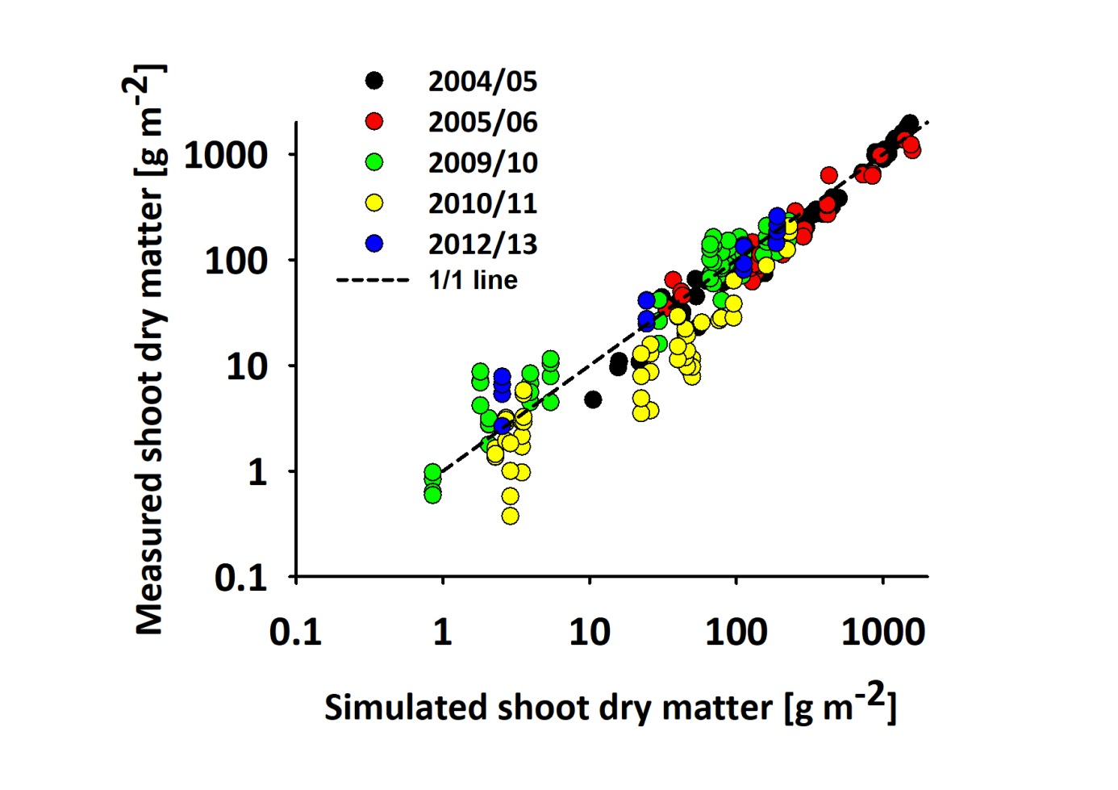
Figure 2: Relation between measured and simulated shoot dry matter of parameterization data, y = -17.88 + 1.02x, r² = 0.95, RMSE = 78.94 g m-2, EF = 0.94, CD = 1.09 (data set 1 and 2).
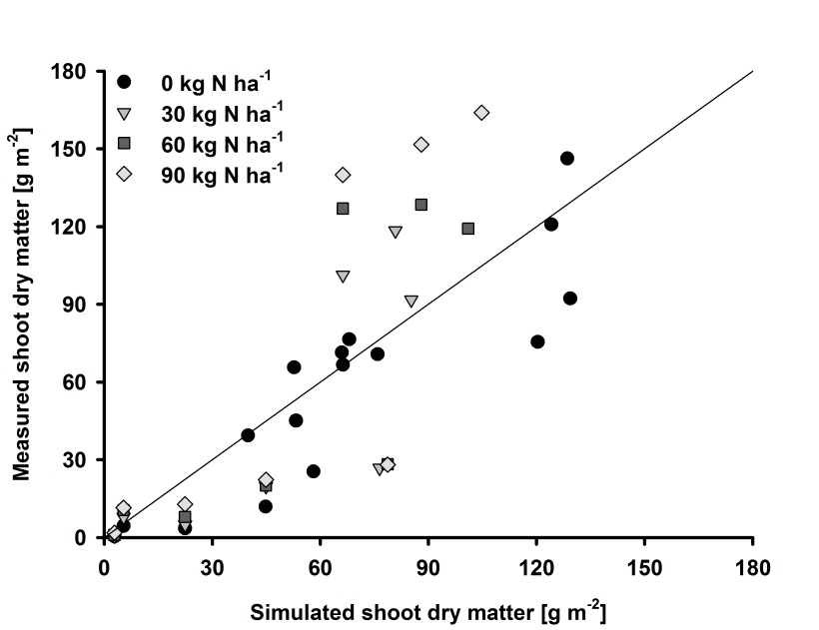
Figure 3: Relation between measured and simulated shoot dry matter at the beginning of regrowth in spring, depending on N supply during autumn growth, y = -5.09 + 1.09x, r² = 0.64 (data set 1 and 2).
Simulated root growth during autumn was in accordance with measured values but before winter in 2009, root dry matter was slightly underestimated, while at start of regrowth in 2010 and 2011, root dry matter tended to be overestimated when rapeseed was sown early (Figure 4).
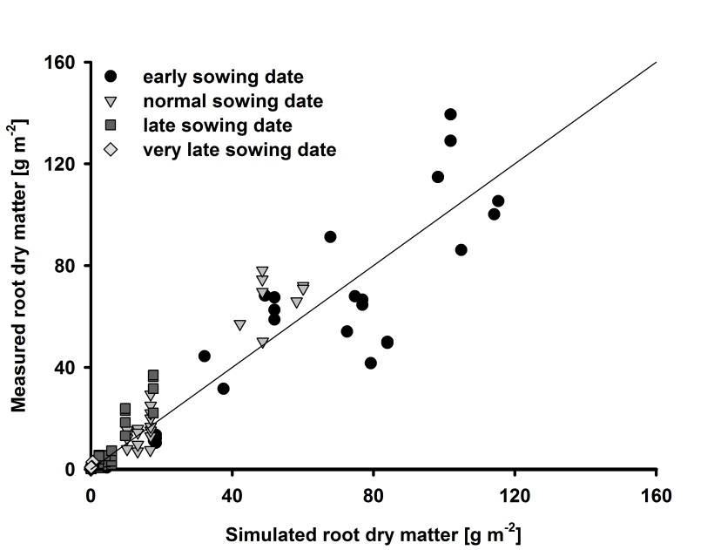
Figure 4: Relation between measured and simulated root dry matter, depending on sowing date, y = 1.32 + 1.00x, r² = 0.89, RMSE = 10.34 g m-2, EF = 0.89, CD = 1.02 (data set 2).
The allometric relation between leaf and stem dry matter in autumn, when leaves are the main sinks of assimilates was well simulated, but effects of senescence due to self-shading and freezing were underestimated for stem growth. Parameter values of the function describing the allometric changes after start of stem elongation (Table 6) because importance of stems as sinks increases. Leaf growth between start of regrowth in spring and harvest was well simulated for high N-treatments. For low N-treatments, maximal leaf dry matter at flowering was slightly overestimated. Stem growth was overestimated before onset of flowering. Simulated stem dry matter during generative growth stages was well simulated for high N treatments but substantially underestimated for treatments without any fertilization.
Before onset of flowering, simulated values of generative dry matter slightly exceeded measured values but afterwards inflorescence and pod growth was well simulated until harvest date.

The measured maximum GAI at the end of flowering varied between 1.8 and 6.6 and was slightly underestimated for high N treatments by the model (Figure 5). N sensitivity of GAI after regrowth in spring was underestimated by the model.
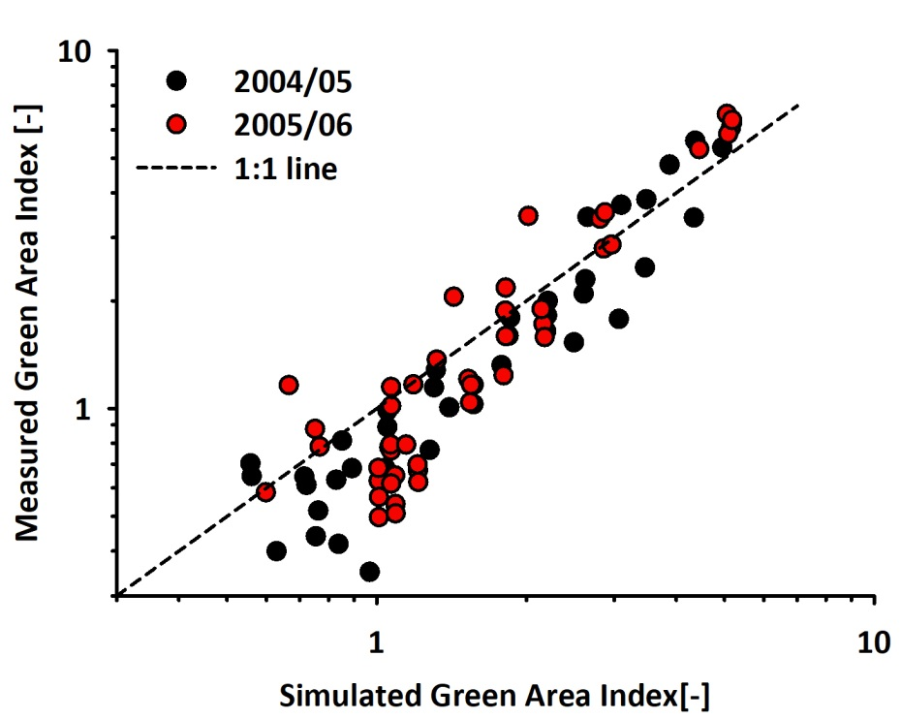
Figure 5: Relation of measured and simulated Green Area Index (GAI) of parameterization data, y = -0.51 * 1.23x, r² = 0.91, RMSE = 0.56, EF = 0.88, CD = 1.63 (data set 1).

N uptake and distribution
N uptake and distribution were estimated under consideration of N dilution, N mineralization and N fertilization.
Simulated shoot N showed the same response pattern compared observed values as dry matter, but with a slightly lower predictive ability. Differences in shoot N amount due to delayed sowing and N treatment were well estimated in the model. Only in 2005, shoot N amount was overestimated after start of regrowth in spring (Figure 6).
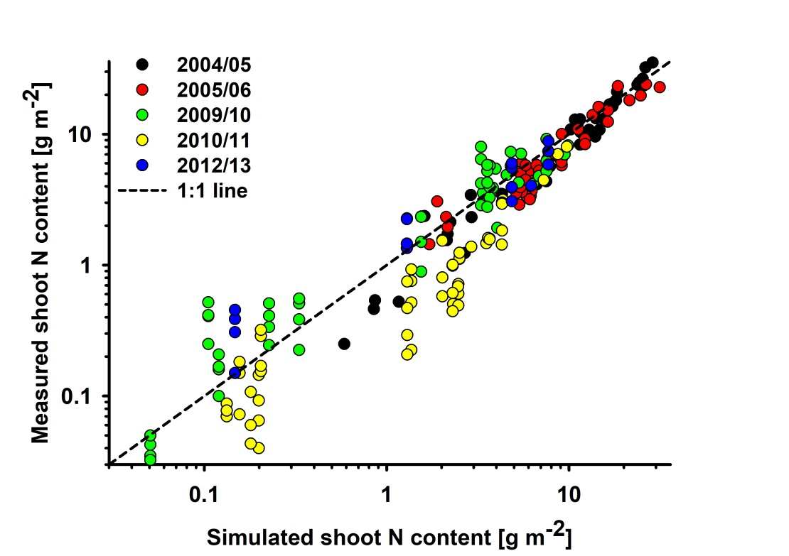
Figure 6: Relation between measured and simulated shoot nitrogen content of parameterization data, y = -0.45 + 0.96x, r² = 0.93, RMSE =1.76 g m-2, EF = 0.92, CD = 0.95 (data set 1 and 2).
In spring, simulated leaf N showed good agreement with measured values. Stem N amount simulations showed accordance with measurements in 2006 for all treatments but an overestimation in 2005.
N amount of generative organs was estimated from actual N uptake and N translocation from vegetative plant organs. It was well estimated in 2006, but underestimated in 2005.

Yield formation
Final seed yield was not accurately represented by the model. Variability due to sowing date and N treatment were simulated appropriate but year-to-year variability was not reproduced satisfactory.
In contrast, oil concentration was well simulated by the model and reproduced variation in the data set.

Validation
Independent data (datasets 3-13) were used to validate model parameterization. Results are shown in Table 8.
Table 8: Accuracy of the model for the validation data sets
Variable (Data set) | N | RMSE | EF
DMShoot  3  4  5  6 | 665  120  372  51  122 | 192.43 g m⁻²  135.21 g m⁻²  240.63 g m⁻²  70.52 g m⁻²  72.28 g m⁻² | 0.86  0.94  0.80  0.98  0.40
NShoot  3  4  5  6 | 622  120  329  51  122 | 4.34 g m⁻²  2.99 g m⁻²  5.20 g m⁻²  3.40 g m⁻²  3.07 g m⁻² | 0.76  0.90  0.72  0.82  0.33
GAI  3  4  5  6 | 41  -  -  41  - | 1.12  -  -  1.12  - | 0.59  -  -  0.59  -
Seed Yield
3
4
5
6
7 (Czech data)
8 (Germany 3 sites)
9 (UK
SWC 0-30 cm  8 | 2116 | 0.0467 | 0.43

Shoot dry matter of dataset 3 (Figure 7), recorded at Hohenschulen between 2004 and 2006, was well simulated during development before winter. In spring, shoot growth of high N-treatments was slightly underestimated in 2004 and overestimated in 2006. In 2005, shoot growth of low N-treatments was overestimated in spring.
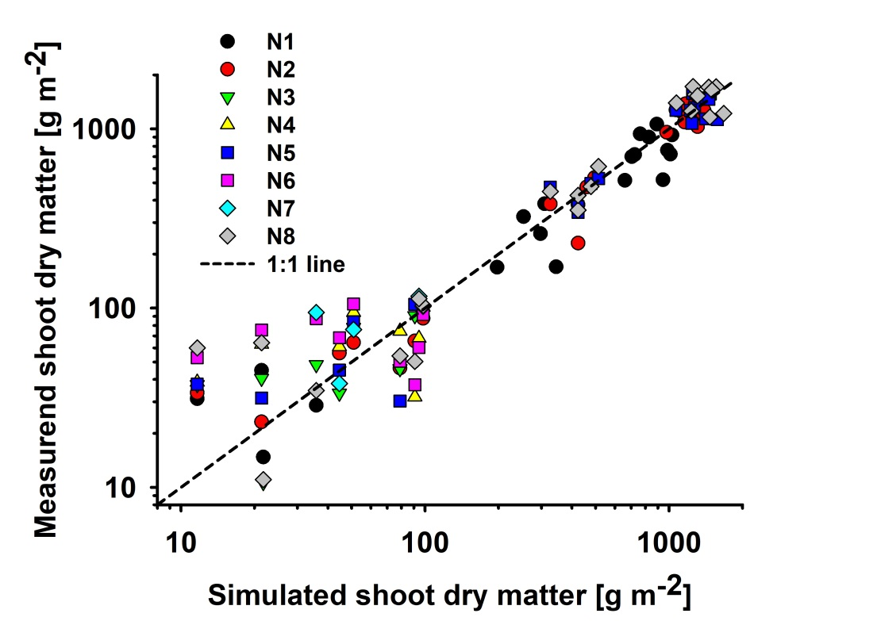
Figure 7: Relation between measured and simulated shoot dry matter of dataset 3, depending on N treatment (N1: 0/0 kg N ha-1, N2: 40/40 kg N ha-1, N3: 80/40 kg N ha-1, N4: 40/80 kg N ha-1, N5: 80/80 kg N ha-1, N6: 120/80 kg N ha-1, N7: 80/120 kg N ha-1, N8: 120/120 kg N ha-1), y = 7.96 * 1.00x, r² = 0.94, RMSE = 135.21 g m-2, EF = 0.94, CD = 1.06.
Shoot dry matter simulations of dataset 4, which was recorded at Hohenschulen between 1992 and 1999, reproduced differences caused by year and N treatment in most cases. In 1995, shoot growth was overestimated after flowering. In 1996, autumn growth was well simulated, but frost senescence was markedly overestimated. Therefore, shoot dry matter was underestimated from the start of regrowth in spring until harvest, especially without N fertilization. In contrast, frost senescence in 1996/1997 was underestimated and shoot dry matter in spring 1997 was overestimated under low N treatments. Shoot N amount of dataset 4 was well estimated until flowering. Afterwards, simulations underestimated and overestimated measured values but no general tendency depending on year or N-treatment was found.
For data from Châlons, the model simulated shoot dry matter under different N treatments well during the whole growth cycle (Figure 8).
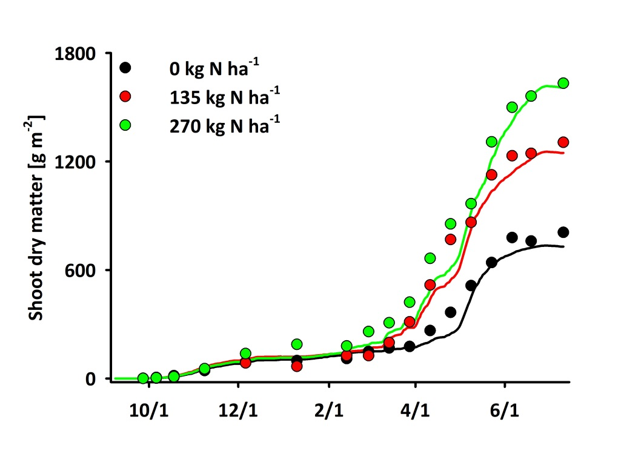
Figure 8: Time course of shoot dry matter accumulation for three different nitrogen fertilization treatments (0 kg N ha⁻¹, 135 kg N ha⁻¹, 270 kg N ha⁻¹) of data from Châlons, RMSE = 240.63 g m⁻², EF = 0.80, CD = 1.10.
Measurements from Châlons also showed an allometric relationship between leaf and stem growth but the model underestimated leaf dry matter during autumn growth. In addition, the model underestimated leaf and stem growth but overestimated pod growth in spring and summer for low N treatments. Generative dry matter of high N treatment was well simulated, but before full flowering growth was slightly overestimated. At Châlons, observed seed dry matter differences due to N limitation were well simulated by the model.
The fourth validation dataset consisted of data from 14 sites, two sowing dates and different experimental periods. In general, variability of shoot dry matter between sites, years and sowing dates was well estimated by the model but absolute values were underestimated. Shoot N amount tended to be underestimated as well.
The fifth validation dataset consisted of yield measurements under different N fertilization rates throughout Europe to simulate different soils and climates. The yields of all the validation data sets are shown in Figure 9, where the symbols are classified by the amount of N fertilizer applied.
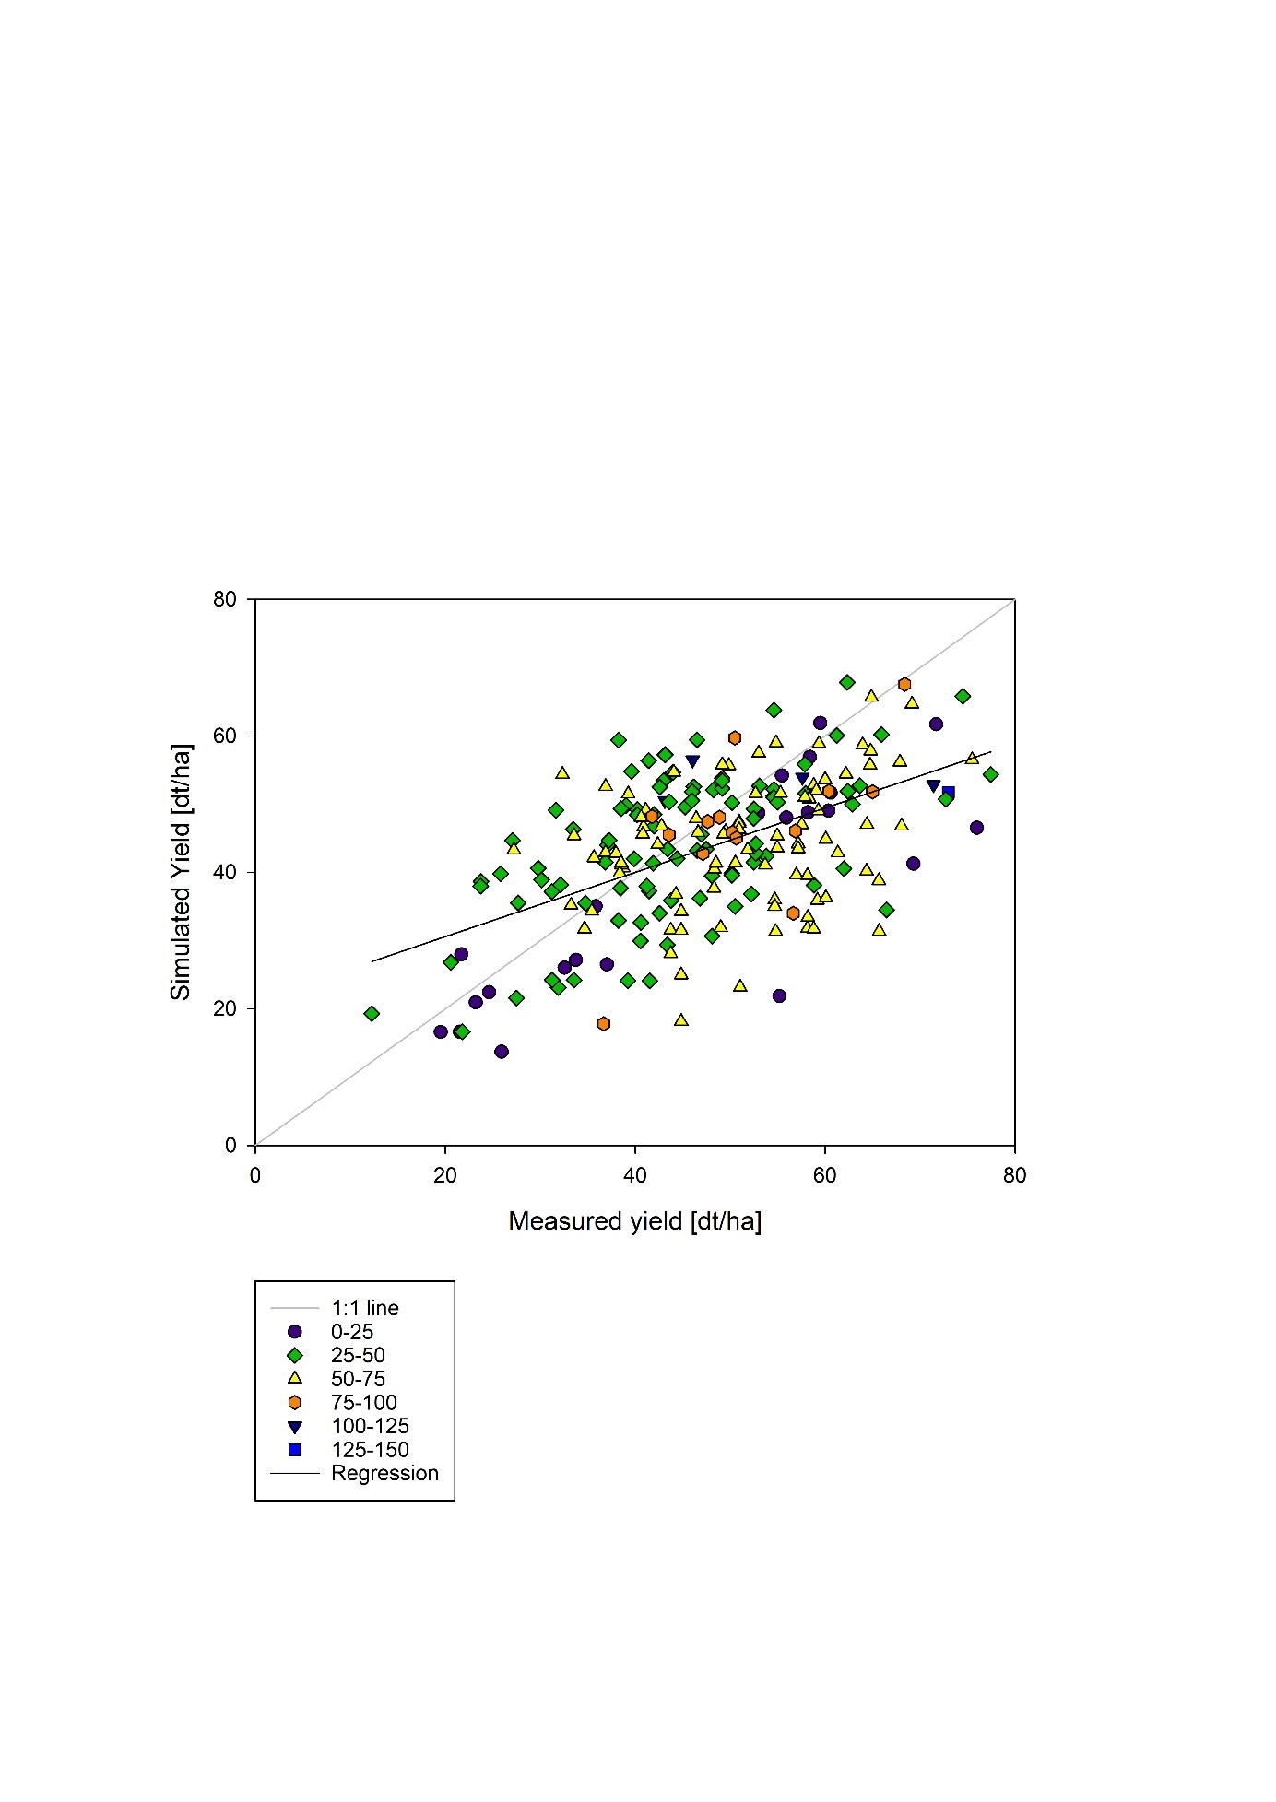
Figure 9: Relation between measured and simulated yields of all validation datasets (y=21.1+0.47x, r2=0.28, RMSE=12.11 dt/ha, EF=0.04, CD= 0.70).

Discussion
We aimed to develop a dynamic crop growth model, which simulates dry matter production and partitioning, as well as N uptake and N distribution of WOSR under optimal and limiting conditions. The model simulates crop growth on a daily basis from sowing until maturity. It is parameterized and validated with data from Germany, Great Britain, France and Czech Republic, and we therefore assume that simulations are valid for temperate regions in Europe. We included physiological processes in the model, with parameters estimated from data from field trials and literature. Severel processes are interdependent. For instance, dry matter production and partitioning influence growth rate of GAI, which by itself determines absorption of radiation and therefore photosynthesis.

Senescence and translocation of assimilates and N are important processes during WOSR development, especially during generative growth (Diepenbrock, 2000, Kierkegaard et al. 2018). Therefore, we implemented senescence caused by self-shading of leaves and pods, freezing and aging and estimated translocation of assimilates and N. Furthermore, WOSR is characterized by the absorption and reflection of radiation by the flower layer and by the simultaneous development of buds, flowers, pods and leaves.
Simulation of dry matter production is based on absorbed radiation by photosynthetic active area of the crop and variable LUE, which describes the conversion from light energy into g of dry matter. In the current model, LUE differs between vegetative (2.7 g MJ⁻¹) and generative growth (3.7 g MJ⁻¹) phases and decreases after pod growth due to senescence of leaves and pods and due to energy intensive lipid synthesis (Habekotté 1997 Evaluation ??). Lower values of LUE in early growth stages were also observed by Justes et al. (2000), who explained this pattern by lower leaf photosynthesis capacity. In addition, they suggested that saturated leaf photosynthesis rate is reached faster at low LAI level. In contrast to previous studies (e.g. Leach et al. 1989, Habekotté 1997) and other rapeseed models (Diepenbrock 2000), LUE is assumed to be constant from inflorescence emergence until end of pod growth. LUE of pods is thus assumed to be similar to LUE of vegetative plant parts. This assumption is supported by studies of Chomel (1981) and Leterme (1985), who estimated LUE values between 3.5 and 5.2 g/MJ PAR between 300°Cd and 600°Cd of pod growth. Several other studies (e.g. ??) have published lower LUE values during generative phases, mostly explained by the energy intensive lipid synthesis. In the present model, the parameters describing LUE during vegetative and generative growth phases are defined as potential LUE. The effective LUE includes reduction by N deficiency, drought stress and conversion losses, but this is not explicitly parameterized in the model. In addition, effects of drought stress on dry matter production are estimated in the model, but not directly derived from field measurements. There may therefore be additional processes associated with drought that is not accounted for in the model, such as pod abortion during period of drought.
Dry matter production is well simulated by the model for the parameterization and validation data sets. Reduction of growth rate due to sowing date, N treatment, water limitation or freezing is well represented. In 1995, dry matter at Hohenschulen was overestimated after flowering, but measured values from flowering until maturity might be doubtful because final shoot dry matter of 800 g m⁻² and yield of 4 Mg ha⁻¹ suggest an unusual high harvest index of 0.5. Data from France suggested that shoot growth was substantially reduced at the end of flowering, while at Hohenschulen, shoot growth continued until the end of pod growth. Uncertainties in calculating shoot dry mass of data set 6 may be caused by missing information of soil texture and water content and mineralized soil N at sowing. In addition, measurements of shoot dry mass were only taken at the end of autumn growth and at the start of regrowth in spring. This adds uncertainties connected with dry matter gain and loss during hibernation. In general, despite uncertainties in some cases, year-to-year and site-to-site variability of shoot dry matter was well estimated with the model as also shown by the model performance statistics.
In our model, simulation of dry matter partitioning is mainly based on allometric approaches. The relations between growth rates of plant organs are mostly independent of N treatment, but crop development determines the distribution patterns of assimilates. For datasets from Hohenschulen, dry matter partitioning is well simulated, while dry matter distribution between leaves and stems is not well represented for the French dataset, especially during autumn growth. These differences are caused by different allometric equations due to the measurements methods (Figure 10). At Châlons, dry matter of leaves and petioles were summarized to calculate leaf dry matter. In contrast, at Hohenschulen, we added petioles to the stems to calculate stem dry matter, because we assume that the photosynthetic activity of petioles is rather similar to the photosynthetic activity of stems than to the one of leaves.
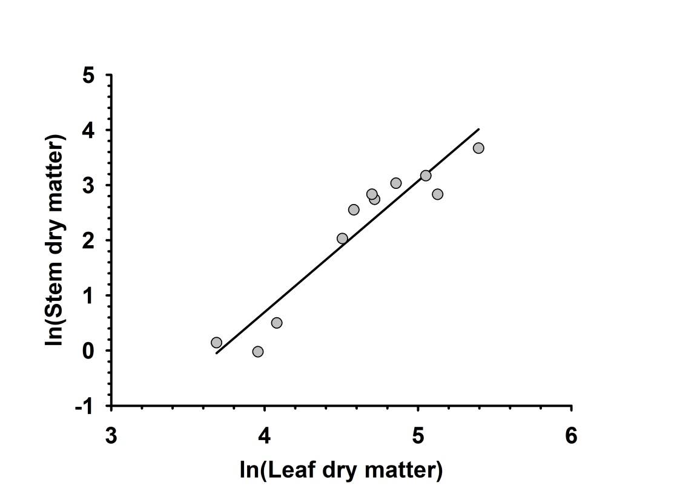
Figure 10: Allometric relation between leaf dry matter and stem dry matter accumulation between emergence and stem elongation of data from Châlons, y = -8.80 + 2.37x, r² = 0.90.
Dry matter partitioning between pod walls and seeds also varies with growth stage. Simulation of pod wall and seed growth is mainly based on assumptions, because data of dry matter of developing pod walls and seeds before maturity were not available. There is thus need to further substantiate these relations.
GAI is well simulated by the model. It is known that N treatment influences GAI and that dry matter production is highly sensitive to GAI < 3 but the model underestimated N sensitivity of GAI after start of regrowth in spring. This indicates that the implementation of senescence process due to self-shading according to the approach of Gabrielle et al. (1998) may be insufficient during spring growth.
N is generally the most limiting nutrient in European cropping systems. Therefore, focus was given to representing N dynamics, including senescence and translocation processes, were in the model. The model had a lower predictive accuracy for N than for dry matter. This could be caused by insufficient data availability, especially for senescence and translocation of N. Therefore, N allocation processes from soil N uptake and N redistribution according to N surpluses and N deficiencies in leaves, stems, pods and roots are mainly based on assumptions.
Yield simulation was not satisfactory, and the approach to calculate final seed yield from shoot dry matter and variable HI was already published by Robertson et al. (1999) and showed promising results. Dynamic approaches, as allometric approaches between pod wall and seed dry matter, were tested but model performance was substantially reduced, probably because growth rates of seeds and pod walls were not measured separately. In addition, final seed yield from combine harvest and plant sampling differ widely and not systematically. Therefore, estimation of combined yield, available in all data sets, is difficult from data from plant sampling. The model does not seem to be able to simulate the high variability in WOSR yield (Berry and Spink, 2006), nevertheless are the modeled yields in the same range as the measured yields. To improve the model results, more data is needed about why the measured WOSR yield has a high variability. From our analysis it seems probable that variation in harvest index is one of the main reasons of yield variability and the current model version uses a fixed harvest index.
Summarizing, the described model has the advantageous to simulate crop growth under optimal and water- and N-limited conditions. Drought stress is implemented and reduces dry matter production linearly. This assumption needs to be verified because parameterization data sets are not adequate to estimate this effect.
Another factor that should be implemented in the model in future is the canopy architecture. Therefore, data from canopy layers and measurements of the distribution of light within the canopy are needed. These information would also increase the knowledge about translocation processes between different plant organs but also between leaves in different canopy layers.

Conclusion
We describe a new dynamic crop growth model for WOSR, simulating dry matter production and partitioning, N uptake and distribution, leaf, stem and pod area expansion and yield formation under optimal and water- and N-limited conditions. The model integrates several physiological processes, which were primarily parameterized from field trials. The model was tested for WOSR crops under different environmental conditions in Northern Europe under different management practices, as sowing date and N treatment. The model well simulated crop development and crop growth processes. The model may therefore be applied for supporting optimization of management strategies and future breeding progress as well as evaluating prospects of WOSR under future climate change.

Robertson, M.J., Lilley, J.M., 2016. Simulation of growth, development and yield of canola (Brassica napus) in APSIM. Crop Pasture Sci. 67, 332-344.
He, D., Wang, E.L., Wang, J., Lilley, J.M., 2017. Genotype x environment x management interactions of canola across China: A simulation study. Agricultural and Forest Meteorology 247, 424-433.
Jing, Q., Shang, J.L., Qian, B.D., Hoogenboom, G., Huffman, T., Liu, J.G., Ma, B.L., Geng, X.Y., Jiao, X.F., Kovacs, J., Walters, D., 2016. Evaluation of the CSM-CROPGRO-Canola Model for Simulating Canola Growth and Yield at West Nipissing in Eastern Canada. Agron. J. 108, 575-584.
Hoffmann, M.P., Jacobs, A., Whitbread, A.M., 2015. Crop modelling based analysis of site-specific production limitations of winter oilseed rape in northern Germany. Field Crop. Res. 178, 49-62.
Weymann, W., Sieling, K., Kage, H., 2017. Organ-specific approaches describing crop growth of winter oilseed rape under optimal and N-limited conditions. European Journal of Agronomy 82, 71-79.
Kirkegaard, J.A., Lilley, J.M., Brill, R.D., Ware, A.H., Walela, C.K., 2018. The critical period for yield and quality determination in canola (Brassica naps L.). Field Crop. Res. 222, 180-188.
Weymann, W., Sieling, K., Kage, H., 2017. Organ-specific approaches describing crop growth of winter oilseed rape under optimal and N-limited conditions. European Journal of Agronomy 82, 71-79.
Bottcher, U., Rampin, E., Hartmann, K., Zanetti, F., Flenet, F., Morison, M., Kage, H., 2016. A phenological model of winter oilseed rape according to the BBCH scale. Crop Pasture Sci. 67, 345-358.

Ratjen, A.M., Lemaire, G., Kage, H., Plénet, D., Justes, E., 2018. Key variables for simulating leaf area and N status: Biomass based relations versus phenology driven approaches. European Journal of Agronomy 100, 110-117.

Berry, P. M., and J. H. Spink. 2006. A physiological analysis of oilseed rape yields: Past and future. The Journal of Agricultural Science 144:381–392.
R.A. Ferreyra et al. 2003: Nonlinear effects of water stress on peanut photosynthesis at crop and leaf scales.
Yin, X., Kersebaum, K.C., Kollas, C., Manevski, K., Baby, S., Beaudoin, N., Öztürk, I., Gaiser, T., Wu, L., Hoffmann, M., Armas-Herrera, C.M., Charfeddine, M., Conradt, T., Contantin, J., Ewert, F., de Cortazar-Atauri, I.G., Giglio, L., Hlavinka, P., Hoffmann, H., Launay, M., Louarn, F., Manderscheid, R., Mary, B., Mirschel, W., Nendel, C., Pacholski, A., Palosuo, T., Ripoche-Wachtrl, D., Rötter, R.P., Ruget, F., Sharif, B., Trnka, M., Ventrella, D., Weigel, H.-J. & Olesen, J.E. (2017). Performance of process-based models for simulation of grain N in crop rotations across Europe. Agricultural Systems 154, 63-77.
Marshall and Squire 1996
Porter and Gawith 1999
Andersen et al. 1996
Malagoli et al 2005

